## IT 112 Assignment 5: DataCamp – Introduction to Git

**Screenshot of Completed Course:**

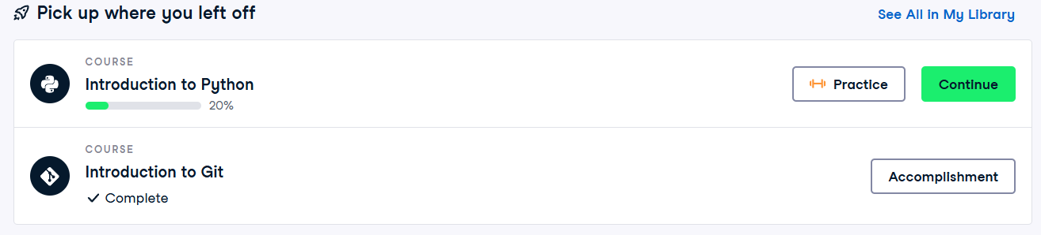

## IT 112 Assignment 16: Setting Up A Flask Environment – VS Code

**Screenshots of Running App & Output:**

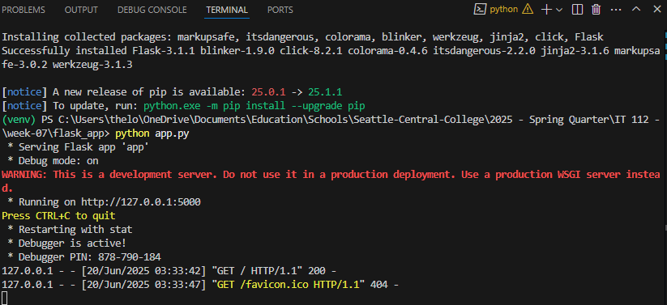

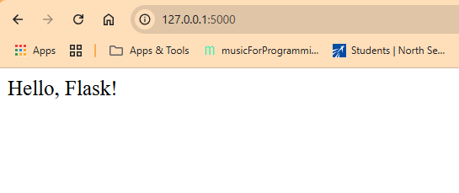

IT 112 Assignment 19: Learn Flask Databases